Job no: o6

Job name :style cSS html backround color change ,padding,margin

Input:

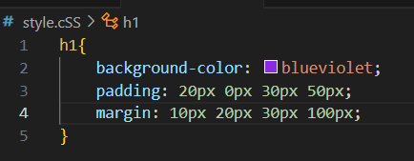

Output:

